IoT & Automation Lab. Record

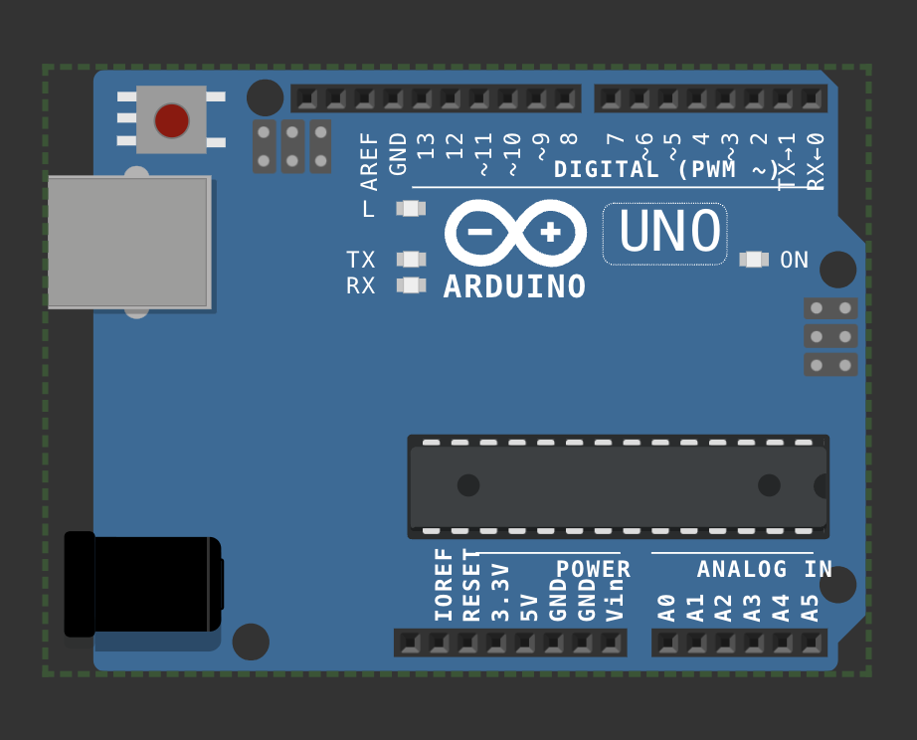**LAB 1: Blinking the in-Built LED**

void setup() {

pinMode(LED_BUILTIN, OUTPUT);

}

void loop() {

digitalWrite(LED_BUILTIN, HIGH); delay(1000);

digitalWrite(LED_BUILTIN,LOW); delay(1000);

}

**LINK** - [**#**](http://www.apple.com/uk) [**WOKWI 1**](https://wokwi.com/projects/410064097034032129)

**LAB 2: Blinking an external LED**

#define led pin 11

void setup() {

pinMode(led pin, OUTPUT);

}

void loop() {

digitalWrite(led_pin, HIGH);

delay(1000);

digitalWrite(led_pin,LOW);

delay(1000);

}

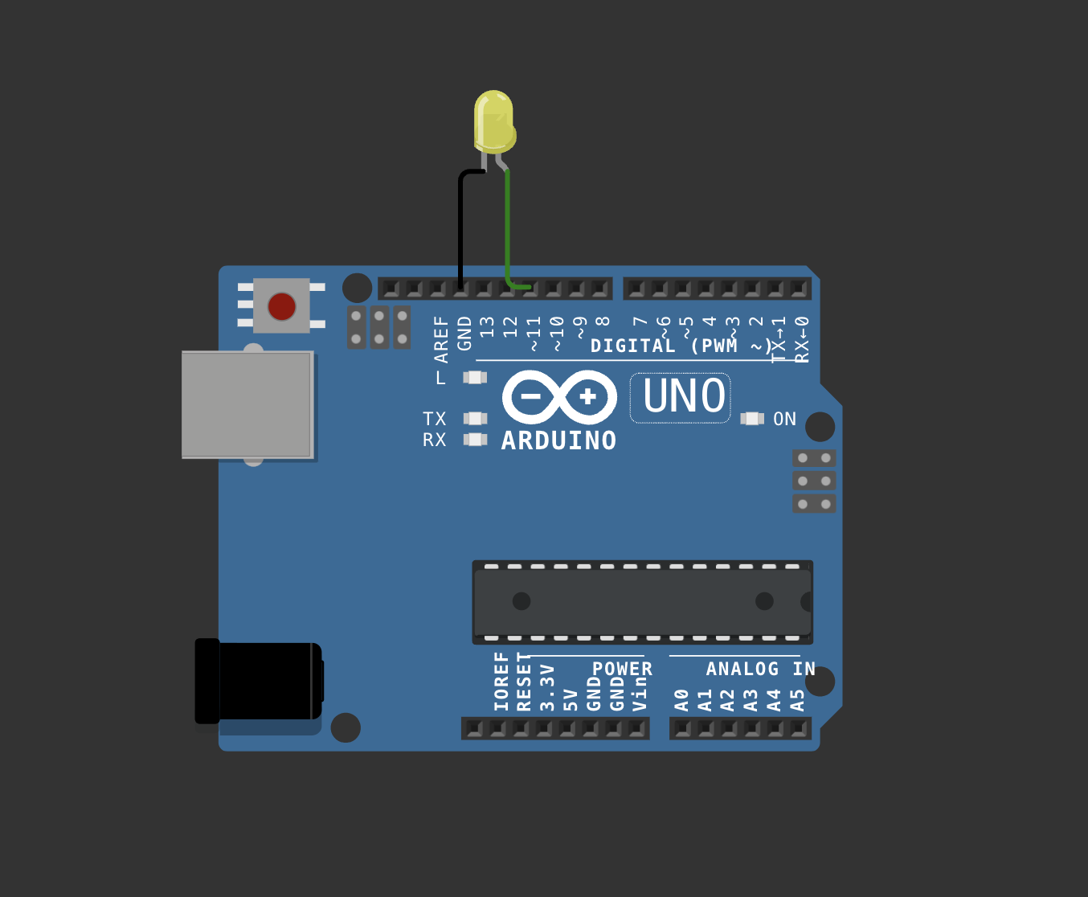

[Link - # wokwi 2](https://wokwi.com/projects/410063574396342273)

# Lab 3: Using DHT sensor

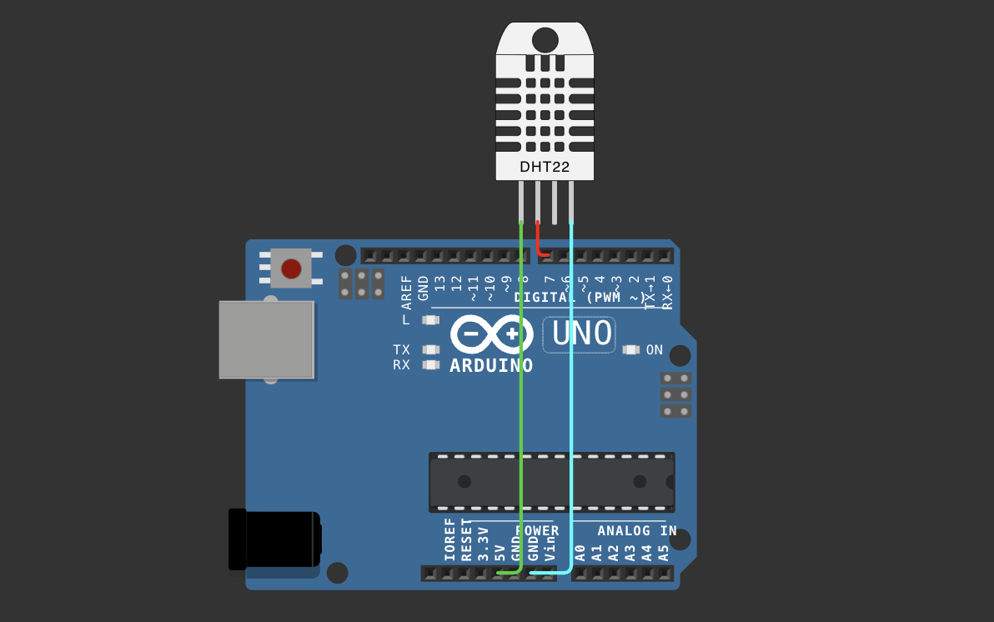

#include <DHT.h>

#define pin 7

#define DHTTYPE DHT22

DHT dht(pin, DHTTYPE);

float humid, temp;

void setup() {

**Serial**.begin(9600);

dht.begin();

}

void loop() {

delay(200);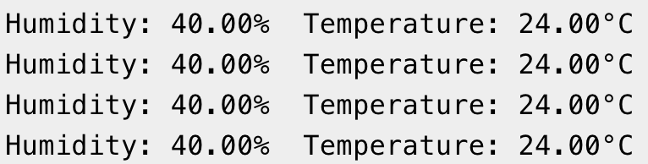

humid = dht.readHumidity();

temp = dht.readTemperature();

**Serial**.print("Humidity: ");

**Serial**.print(humid);

**Serial**.print("% Temperature: ");

**Serial**.print(temp);

**Serial**.println("°C");

delay(1000);

}

LINK - [#Wokwi 3](https://wokwi.com/projects/410064543004003329)

# Lab 4: Using Mosquitto MQTT (Pub-Sub):

Starting Mosquitto MQTT:

# 

Setting up Publisher & Sending Message:

# 

Setting up Subscriber & Receiving Message:

# 

# Lab 5: Building a web app using Node-Red to fetch DHT sensor data and display it on the web app dashboard:

Installing & Initialising node red:

* Open node.js > npm install node-red-dashboard
* [postinstallation] > elevated cmd: node-red

In client application, browsed localhost:1880 [ accessing node red]:

* Inside the nodered window, a flow was created w/ the nodes as:

            > serial-in ( arduino uno r3 board )

            > debugger

            > dht function

> 2 gauges (humidity& temperature)

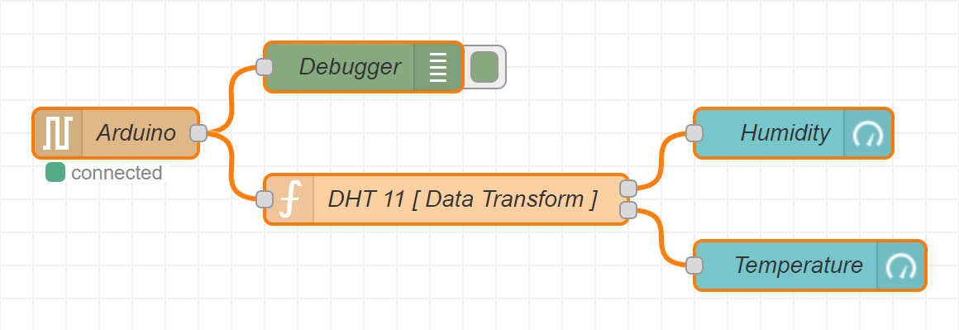

* Serial in node: configured it to read from the correct serial port where my arduino is connected (e.g., com7) > set the baud rate to 9600.
* Configure the dht function as:

var m = msg.payload.split(',');

if (m.length === 2) {

var h = { payload: parsefloat(m[0]) };

            var t = { payload: parsefloat(m[1]) };

            return [h, t];

} else {

return null; }

* Adjusting Gauge Nodes:

Humidity:

        - Title as “ Humidity ”.

        - Value format as ‘ {{value}}% ’.

        - Range Value: 0 ~ 100 %.

Temperatue:

        - Title as ' Temperature '.

        - Value format as ‘ {{value}}°C ’.

*\*\*Ensure that Humidity & Temperature are in the same group*

Deployment:

* Uploaded DHT11 /22 Sketch to the Arduino Board through its IDE:

#include <dht.h>

#define dhtpin 3

#define dhttype dht11

dht dht(dhtpin, dhttype);

void setup() {

serial.begin(9600);

dht.begin();

}

void loop()  {

float h = dht.readhumidity();

float t = dht.readtemperature();

if (isnan(h) || isnan(t)) {

serial.println("failed to read from dht sensor!");

}

else {

serial.println(string(h) + "," + string(t));

}

delay(2000);

}

* After uploading this sketch, close the IDE.
* Deploy the flow in NodeRED.
* Check the Dashboard in the upper-right corner, for the Humidity and Temperature Gauge.

OUTPUT ON THE DASHBOARD:

